DNA Simulation of Boolean Circuits
Martyn Amos, and Paul E. Dunne
Technical Report CTAG97009, Department of Computer Science, University of Liverpool, 1997
Abstract
Previously propose simulations have been shown to run in time proportional to the size of th circuit. The simulation we present here runs in time proportional to the depth of the circuit.
It is well-known that the NAND function provides a complete basis by itself, we restrict our model to the simulation of such gates within only two input and one ouput.

Introduction
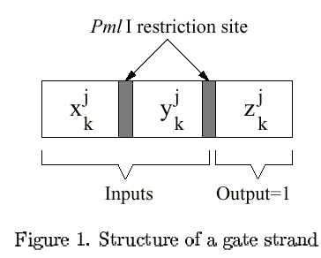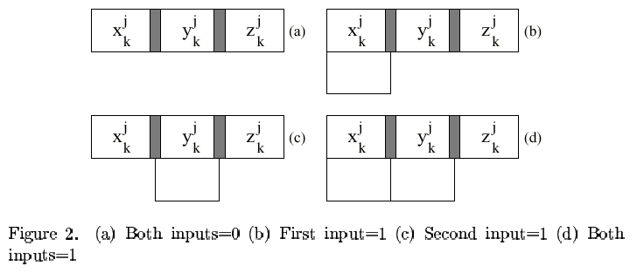
Method
- At k pour into T_{k} the strands in tubeT_{k-1}. These anneal to the gate strands at the appropriate position.
- Add liage to T_{k} in order to seal any “nicks”.
- Add to T_{k} the restrction enzyme PmlI for cleaving only hose strands that have both input strands annealed to them.
- Denature the strands and run T_{k} through a gel, retaining only those strands of length 3l.
- Add tube Sk to tube T_{k} for anneal to the second restriction site.
- Add enzyme PmlI to tube T_{k}, which “snips of the z section”.
- Denature and run T_{k} through another gel, this time retaining only strands of length l. This tube, T_{k} of retained strands forms the input to T_{k+1}.

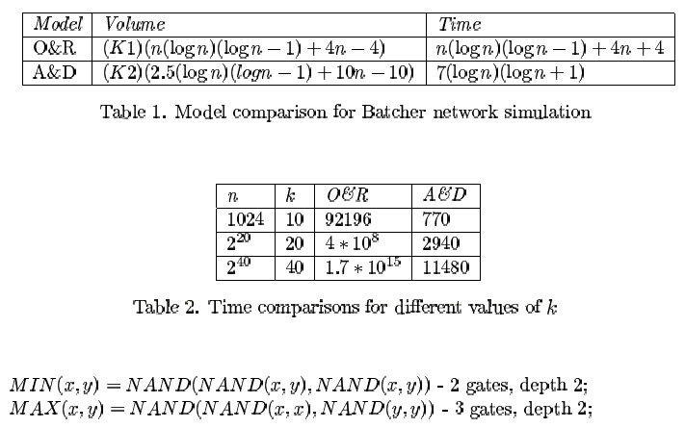
Conclusion
Roweis et al. claim that their sticker model is feasible using 2⁵⁶ distinct strands. We therefore conclude that our implementation is technically feasible for input size that could not be physically realised in silico using existing fabrication techniques.

Created by : Hung-Yuan Wang
Date : Oct. 2, 2001

